**Mini Project Report on**



**Image Classification using Deep Learning**



**Submitted in partial fulfilment of the requirement for the award of the degree of**

**BACHELOR OF TECHNOLOGY**

**IN**

**COMPUTER SCIENCE & ENGINEERING**

**Submitted by:**

**Student Name**  **University Roll No.**

Gauri Gupta 2018809

***Under the Mentorship of***

**Prof. Ashwini Kumar**

**Assistant Professor**



**Department of Computer Science and Engineering**

**Graphic Era (Deemed to be University)**

**Dehradun, Uttarakhand**

**January-2024**



**CANDIDATE’S DECLARATION**

I hereby certify that the work which is being presented in the project report entitled **“Image Classification using deep learning”** in partial fulfillment of the requirements for the award of the Degree of Bachelor of Technology in Computer Science and Engineeringof the Graphic Era (Deemed to be University), Dehradun shall be carried out by the under the mentorship of **Prof. Ashwani Kumar, Assistant Professor**, Department of Computer Science and Engineering, Graphic Era (Deemed to be University), Dehradun.

Name University Roll no

Gauri Gupta 2018809

**Table of Contents**

|  |  |  |
| --- | --- | --- |
| **Chapter No.** | **Description** | **Page No.** |
| Chapter 1 | Introduction | **1-2** |
| Chapter 2 | Literature Survey | **3-4** |
| Chapter 3 | Methodology | **5-6** |
| Chapter 4 | Result and Discussion | **7-9** |
| Chapter 5 | Conclusion and Future Work | **10** |
|  | References | **11** |

**Chapter 1**

**Introduction**

According to the Internet Center (IDC), it is projected that the global data volume will reach 45ZB by 2020, with approximately 70% of this data consisting of images or videos. Computer vision has played a crucial role in extracting valuable information from these visual formats, particularly in the field of image classification.

The origins of image classification can be traced back to the late 1950s, and since then, it has found widespread applications in various engineering disciplines, the medical field, human-vehicle tracking, fingerprint analysis, disaster management, and security. Classification involves organizing entities into systematic groups and categories based on their features. Image classification, in particular, aims to narrow the gap between computer vision and human vision by training computers with relevant data. During this process, images are categorized into prescribed classes based on their visual content.

Several image classification methods have been proposed, broadly categorized into four groups:

1. **Statistics-Based Image Classification**:This method relies on statistical models, such as the Markov model and Bayesian model, with the objective of minimizing errors.

2. **Texture, Local Features, and Traditional Colors**-Based Image Classification:** This approach involves the analysis of textures, local features, and traditional colors for classification purposes.

3. **Shallow Learning-Based Image Classification**:This category encompasses methods that utilize shallow learning techniques.

4. **Deep Learning-Based Image Classification**: The advent of deep learning has significantly impacted image classification, with methods employing deep neural networks to extract complex features.

The traditional approach for image classification involves machine learning, consisting of a feature extraction module that identifies crucial features like edges and textures, and a classification module that categorizes images based on the extracted features. However, machine learning-based image classification has limitations, as it can only extract a specific set of features from images and may face challenges with features beyond the scope of its training data.

**Chapter 2**

**Literature Survey**

Neural Networks function as mathematical models designed to address optimization problems, employing neurons as the fundamental computation units. Also known as Artificial Neural Networks (ANN), these systems come in various types inspired by the functionalities of human brain neurons and networks, effectively performing tasks like segmentation and classification.

There are two primary types of ANNs:

1. **Feedback ANN**: This type incorporates feeding the output back into the network to internally achieve optimal results, making it suitable for resolving optimization problems.

2. **Feed Forward ANN**: A simple neural network comprising an input layer, an output layer, and one or more layers of neurons. The network's power is assessed by evaluating its output through the input, observing the collective behavior of connected neurons to determine the output.

**Proposed System:**

The proposed system follows the depicted architecture below. Initially, the system captures an image through a digital camera or retrieves it from a database, normalizing each image to a predefined size for subsequent processing. Feature extraction methods such as M-BTC (Block Transition Coding) and Histogram Equalization are applied for dimensionality reduction.

Feature vectors are then created for each image through various extraction methods, and these processed images are input into the Neural Network (NN) for the classification process.

Various open-source frameworks, with TensorFlow being the most popular, are utilized for implementing deep learning. TensorFlow facilitates the development of neural networks for recognizing objects, shapes, and speech. In contrast to traditional applications where computers are manually provided knowledge about object features, deep learning involves building neural networks that autonomously identify image features. The neural network comprises an input layer, hidden layers, and an output layer, learning patterns within different images for autonomous classification.

The system focuses on creating different types of neural networks that train themselves by observing patterns, with a current emphasis on four classes (indoor, outdoor, cat, dog). Developed using Python and the TensorFlow framework for both CPU and GPU-based systems, the system's performance is evaluated by parameters such as execution time and classification accuracy.

Each neuron in the neural network contains weights calculated based on the associated function. The input is propagated to the next layer, and weights are adjusted based on the error rate, typically through back-propagation, involving the minimization of the difference between actual and obtained results.

**Chapter 3**

**Methodology**

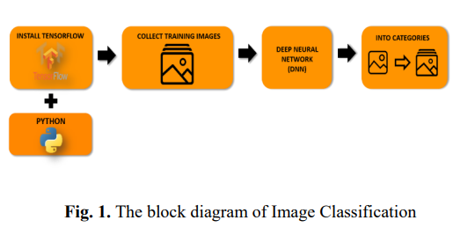

The framework depicted in Figure 1 delineates the image classification process, incorporating deep neural networks (DNN) across four distinct phases. Each of these phases is executed using the open-source software TensorFlow and Python as the programming language. The workflow commences with the aggregation of training images, sourced from ImageNet, a platform associated with the Large Scale Visual Recognition Challenge—an annual competition since 2010 contributing to the 'big data' revolution.

The primary objective of this research paper is to classify thousands of plant images into distinct categories to recognize their diseases. These images, obtained freely from ImageNet, focus on 38 type of plant diseases. Each disease type encompasses numerous images exhibiting variations in size, color, and perspective. The input images are standardized to a fixed size of 224x224 RGB, and the convolution process is configured using ResNet, renowned for its efficiency in producing convolutional neural networks.

The DNN process for classifying flower images, wherein ResNet serves as the trainer, incorporating small and efficient deep neural networks. The configuration of ResNet involves setting the input image resolution to 224 and the size of the model to 0.50.

The classification system implemented using TensorFlow and Python. The process begins with the collection of leaf images, encompassing 38 types,some are:Apple Scab,Tomato late blight,Frape leaf blight etc. These input images undergo training with DNN until the system recognizes each of the 3670 images. During testing, the system classifies images into the five flower types. In case of inaccurate outputs, the process iterates back to the DNN phase until correct classifications are achieved. The process concludes when all images are accurately classified into their respective flower types.

**Chapter 4**

**Result and Discussion**

Table 2 shows the performance matrices for each model developed for each of the plant. We can observe that the accuracy scores are nearly equal to f1 scores. This is because of balanced number of false negative and false positive predictions. This is considered as best case for any machine learning algorithm. The average accuracy was 96%.

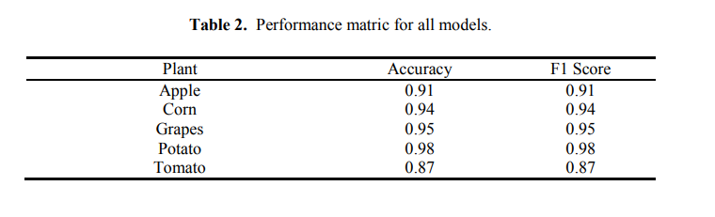

Fig. 4 shows the confusion matrices for each of the model. With the help of confusion matrices, number of false negatives, false positives, true predictions can be analyzed. Fig. 5 shows the receiver operating characteristic (ROC) curve for each of the model. An ROC curve is a graph showing the performance of a classification model at all classification thresholds. It depends upon two parameters, true positive rate and false positive rate.

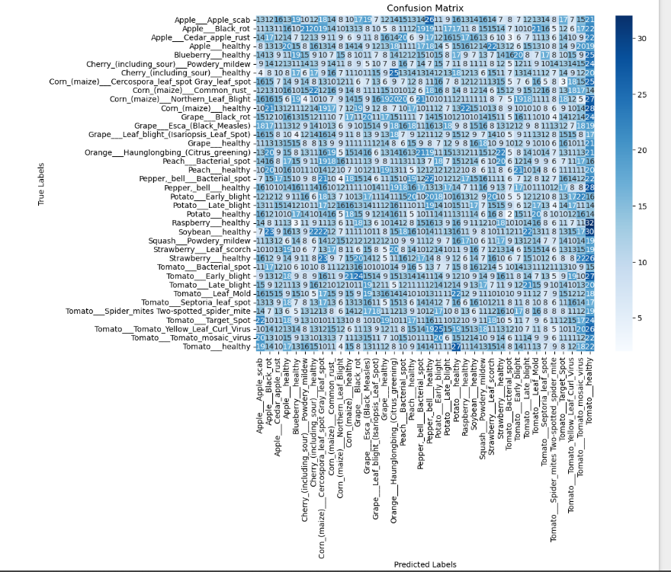

Figure:4

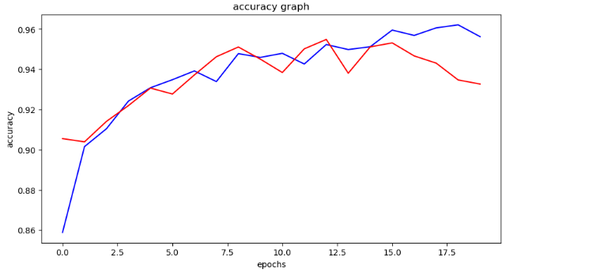

Figure:5

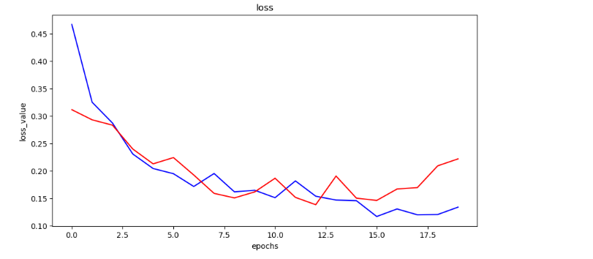

Figure:6

**Chapter 5**

**Conclusion and Future Work**

We have successfully developed a computer vision based system for plant disease detection with average 93% accuracy and 0.93 F1 score. Also the proposed system is computationally efficient because of the use of statistical image processing and machine learning model.

We can observe that our technique is accurate and efficient compared with other systems. Also it won't require a specialized hardware, makes it cost effective solution.

**References**

[1] Gregor, K., Danihelka, I., Graves, A., Rezende, D. J., & Wierstra, D. (2015). DRAW: A Recurrent Neural Network For Image Generation. <https://doi.org/10.1038/nature14236>

[2] Rastegari, M., Ordonez, V., Redmon, J., & Farhadi, A. (2016). XNOR-net: Imagenet classification using binary convolutional neural networks. Lecture Notes in Computer Science (Including Subseries Lecture Notes in Artificial Intelligence and Lecture Notes in Bioinformatics), 9908 LNCS, 525–542. https://doi.org/10.1007/978-3-319-46493-0_32

[3] Kamavisdar, P., Saluja, S., & Agrawal, S. (2013). A survey on image classification approaches and techniques. Nternational Journal of Advanced Research in Computer and Communication Engineering, 2(1), 1005–1009. <https://doi.org/10.23883/IJRTER.2017.3033.XTS7Z>

[4] Pasolli, E., Melgani, F., Tuia, D., Pacifici, F., & Emery, W. J. (2014). SVM active learning approach for image classification using spatial information. IEEE Transactions on Geoscience and Remote Sensing, 52(4), 2217–2223. https://doi.org/10.1109/TGRS.2013.2258676